**Task 1 : Create a Spring boot project configure with Github and database  write junit test case for a student  details name , age ,salary and create a jar and deploy it.**

**Student application:**

package com.upendra.student;

import org.springframework.boot.SpringApplication;

import org.springframework.boot.autoconfigure.SpringBootApplication;

import io.swagger.v3.oas.annotations.OpenAPIDefinition;

import io.swagger.v3.oas.annotations.info.Info;

@OpenAPIDefinition(info = @Info(title = "student"))

@SpringBootApplication

public class StudentApplication {

public static void main(String[] args) {

SpringApplication.run(StudentApplication.class, args);

}

}

Controller:

package com.upendra.student.controller;

import java.security.PublicKey;

import java.util.List;

import org.springframework.beans.factory.annotation.Autowired;

import org.springframework.web.bind.annotation.GetMapping;

import org.springframework.web.bind.annotation.PathVariable;

import org.springframework.web.bind.annotation.PostMapping;

import org.springframework.web.bind.annotation.RequestBody;

import org.springframework.web.bind.annotation.RequestMapping;

import org.springframework.web.bind.annotation.RestController;

import com.upendra.student.model.Student;

import com.upendra.student.service.StudentService;

@RestController

@RequestMapping("/student")

public class StudentCont {

@Autowired

StudentService studentService;

@GetMapping("/getByName/{name}")

public List<Student> getBySytudent(@PathVariable("name") String name) {

return studentService.findByName(name);

}

@GetMapping("/getByAge/{age}")

public List<Student> getByAge(@PathVariable("age") int age) {

return studentService.findByAge(age);

}

@GetMapping("/getBySalary/{salary}")

public List<Student> getBySalary(@PathVariable("salary") long salary) {

return studentService.findBySalary(salary);

}

@PostMapping("/post")

public Student post(@RequestBody Student student)

{

return studentService.post(student);

}

}

Service:

package com.upendra.student.service;

import java.util.List;

import org.springframework.beans.factory.annotation.Autowired;

import org.springframework.stereotype.Service;

import org.springframework.web.bind.annotation.RequestBody;

import com.upendra.student.model.Student;

import com.upendra.student.repo.StudentRepo;

@Service

public class StudentService {

@Autowired

StudentRepo repo;

public List<Student> findByName(String name) {

return repo.findByName(name);

}

public List<Student> findByAge(int age) {

return repo.findByAge(age);

}

public List<Student> findBySalary(long salary) {

return repo.findBySalary(salary);

}

public Student post(Student student)

{

return repo.save(student);

}

}

Repository

package com.upendra.student.repo;

import java.util.List;

import org.springframework.data.mongodb.repository.MongoRepository;

import org.springframework.stereotype.Repository;

import com.upendra.student.model.Student;

@Repository

public interface StudentRepo extends MongoRepository<Student, String>{

List<Student> findByName(String name);

List<Student> findBySalary(long salary);

List<Student> findByAge(int age);

}

Test Classes:

FOR CONTROLER

package com.upendra.student.controller;

import static org.junit.jupiter.api.Assertions.*;

import static org.mockito.Mockito.when;

import java.util.ArrayList;

import java.util.List;

import org.junit.jupiter.api.Test;

import org.springframework.beans.factory.annotation.Autowired;

import org.springframework.boot.test.autoconfigure.web.servlet.WebMvcTest;

import org.springframework.boot.test.mock.mockito.MockBean;

import org.springframework.test.web.servlet.MockMvc;

import org.springframework.web.servlet.config.annotation.EnableWebMvc;

import com.upendra.student.model.Student;

import com.upendra.student.service.StudentService;

@WebMvcTest(value = StudentCont.class)

class StudentContTest {

@Autowired

MockMvc mockMvc;

@MockBean

StudentService studentService;

@Test

void testGetByName() {

List<Student> list = new ArrayList<>();

Student student = new Student("Upendra", 44, 40000000);

list.add(student);

when(studentService.findByName("upendra")).thenReturn(list);

}

@Test

void testGetBySalary() {

List<Student> list = new ArrayList<>();

Student student = new Student("Upendra", 44, 40000000);

list.add(student);

when(studentService.findBySalary(246465)).thenReturn(list);

}

@Test

void testGetByAge() {

List<Student> list = new ArrayList<>();

Student student = new Student("Upendra", 44, 40000000);

list.add(student);

when(studentService.findByAge(0)).thenReturn(list);

}

}

FOR SERVICE:

package com.upendra.student.service;

import static org.junit.jupiter.api.Assertions.*;

import static org.mockito.Mockito.when;

import java.util.ArrayList;

import java.util.List;

import org.junit.jupiter.api.Test;

import org.springframework.beans.factory.annotation.Autowired;

import org.springframework.boot.test.autoconfigure.web.servlet.WebMvcTest;

import org.springframework.boot.test.mock.mockito.MockBean;

import org.springframework.test.web.servlet.MockMvc;

import org.springframework.web.servlet.config.annotation.EnableWebMvc;

import com.upendra.student.model.Student;

@WebMvcTest(value = StudentService.class)

class StudentServiceTest {

@Autowired

MockMvc mockMvc;

@MockBean

StudentService studentService;

@Test

void testGetByName() {

List<Student> list = new ArrayList<>();

Student student = new Student("Upendra", 44, 40000000);

list.add(student);

when(studentService.findByName("upendra")).thenReturn(list);

}

@Test

void testGetBySalary() {

List<Student> list = new ArrayList<>();

Student student = new Student("Upendra", 44, 40000000);

list.add(student);

when(studentService.findBySalary(246465)).thenReturn(list);

}

@Test

void testGetByAge() {

List<Student> list = new ArrayList<>();

Student student = new Student("Upendra", 44, 40000000);

list.add(student);

when(studentService.findByAge(0)).thenReturn(list);

}

}

Test coverage Screen shot :

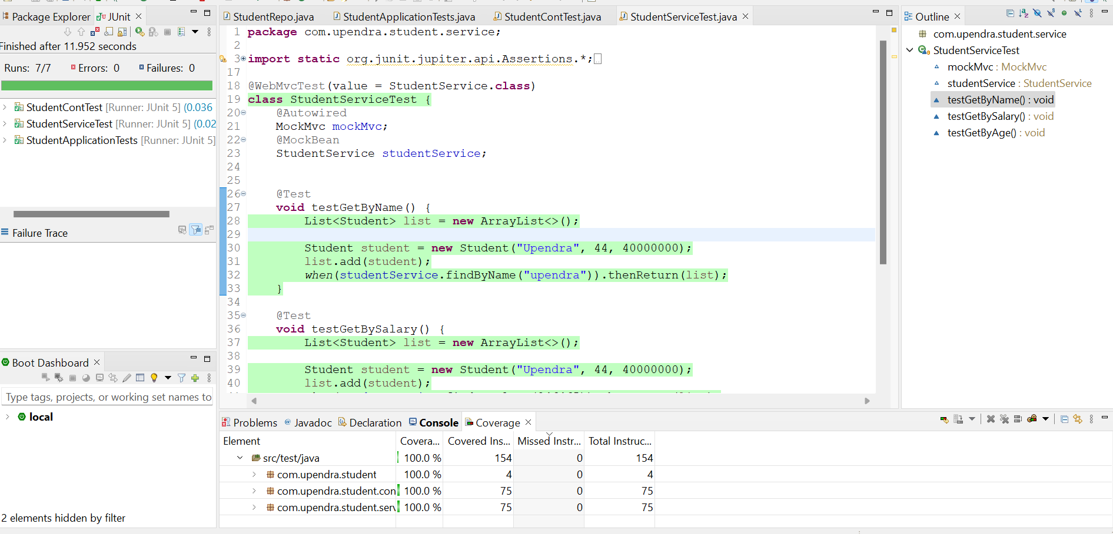

Github Screen shot:

